Fast Order API – Draft Discussion
Created Feb 23, 2010 by Steven Sinclair

Business Goal
In the current competitive marketplace for options trading, the speed with which an exchange can accept and acknowledge an order is critical. This can best be achieved in the current trading system by providing a new order API for firms to use, allowing them to enter a restricted order definition and processing a narrower set of validations and routing decisions.
It is the goal of this project to make options order processing comparable to stock order processing: order response times

Order Entry (firm to CAS)
The API selected to represent a new order entry has tentatively been decided to be FIX. This will allow for a non-CORBA interface without requiring large changes by clients. Existing FIX engine technology in the CD Client group can also be leveraged.
The disadvantage to using FIX rather than a proprietary messaging protocol is that we are required to conform to the text-based FIX protocol. We are currently dependent on 3rd party software (Appia) for FIX protocol handling, which introduced uncontrolled and difficult to measure latency in the system.

Order Entry Restrictions
- The new order API will not accept complex orders
- No cross, AIM, or other paired-order functionality
- Only day orders will be accepted.
- TODO: List other restrictions, such as:
  - Contingency types
  - Origin codes
  - Auction responses?

Order Entry (CAS to BC)

Bypassing OHS
We are proposing bypassing the OHS process altogether and exposing an DirectOrderEntryService on the trade server (TS) itself: the “TS-DDOES”. This will avoid any interprocess delays between OHS and TS, and additionally avoid the cost of demarshalling and remarshalling the information.
More research is necessary to determine if there are any OHS features that are critical to the offloading of the processing to TS: the disadvantage to OHS from the order path is that most of the OHS features will be unavailable to these new types of orders.
Duplicate order id detection will be more difficult to enforce. Validating order id's would only be practical per trade server, not per BC as is currently done.

Synchronous Call
The call from the client to the trade server will be a blocking 2-way call. Using a TCP “one way” or multi-cast protocol to send the order from the client to the trade server may encourage excessive order flow that might back up on the trade server for processing, which could in turn degrade performance rather than enhance it.
The synchronous call will guarantee that orders from a specific FIX connection will be processed sequentially.
Other issues raised with a CAS-originated one-way call are moot: order id (“high/low id”) assignment, UUID management in the CAS, fabricating “new” acknowledgment messages to the firm, et cetera.

Synchronous Call Result
We are considering including fill report information on the result of the order entry call. This will require that the result of the order entry method supply:
- A sequence of fill reports
- A cancel volume (to accommodate IOC and FOK orders)
- The “high/low” order id
The principal concern with this approach concerns drop-copies. OHS will have to continue to publish these reports, while the user should not be delivered duplicate reports. This is principally a challenge for the Client team to avoid redundant reports.

Message Format
There are two proposed formats for the CAS → BC message: either a CORBA struct or a “Message Codec” formatted byte array over CORBA. The advantage to using a CORBA struct is that it uses an existing, well-established technology. The advantage to using the message codec for order message formatting is that it may compress the message significantly more than a typical.

Communication With OHS
OHS will still retain the “master copy” of the order. After the trade server processes a new order, it will publish either a fill, cancel, or book event (or some combination thereof), but first a “new order” message will be published ahead of these to instruct OHS to create this new order. All subsequent operations on the order in the trade server will be communicated to OHS via the existing IOSC event messages.

Identifying “Fast” Orders
Orders will be identified as “Fast” order types by back-office and other systems via the creation of a new order “source” type. Current source types include “C” (CMI), “L” (Linkage), et cetera. The new source type may be “D” for Direct order entry. This will allow for various data mining operations and analyses to identify the new order type.

Legacy Operations on the new Orders
Since OHS will retain the master copy of the order, it should be capable of honoring all existing API methods on the order:
- Cancel requests
- Cancel/replace requests
- OMT Reroutes
- Order queries
There is a potential issue with respect to order locking. It must be communicated effectively to the firms that a legacy operation entered soon (milliseconds) after a “fast” order entry will not necessarily succeed, since the order may not have been processed by OHS yet (even though it may have already executed on the trade server).

Other “Fast” Order Operations

Cancel Request
Cancel requests should be submitted to the TS-DOES. The response (method result) of a cancel will be the cancel report. Note that the cancel report will still be delivered to OHS for updating the order, etc.

Cancel/Replace Request
From a systems perspective, we would prefer to not support cancel/replace functionality on this new order path. If business dictates that this is a critical function, then the OHS code base for supporting this will be supported in the trade server.

Durability of “Fast” Orders
Since the only time-in-force code supported is DAY, there is no inter-day order recovery required.
On fail-over, these orders will not necessarily be recovered. Note that we would have to do additional development work on OHS to prevent the recovery of such orders.

Order Validations
A minimum of order validations will be executed against the new order type. Other than field value limits, logical restrictions on the order entry will apply. In all cases, any validation failure will result in an exception being propagated back to the firm (the order will not remain in the CBOEDirect system).x
- Order size reasonableness: a firm routing property will be checked to verify if the order's size is beyond a preset limit.
- Order super-marketability: a trading property will be checked to see if the order is priced too far through the current market price. For example, a $20 sell against a $0.10 bid would likely be rejected.
- User id and firm number will be validated to ensure they are valid users in the system.
- Contingency type validated with respect to contingent price and volume
- Market-priced order validated with respect to order origin type
- TODO – Identify further “edit checks” to run against the order.

Order Entry Information

The following fields have been abstracted from the OrderEntryStruct. If defined as a “codec”, an order would take at most 141 bytes + message overhead of 12 bytes (153 bytes).

Formatted message data would take 43 bytes (typical non-contingent message) to 141 bytes (maximum):
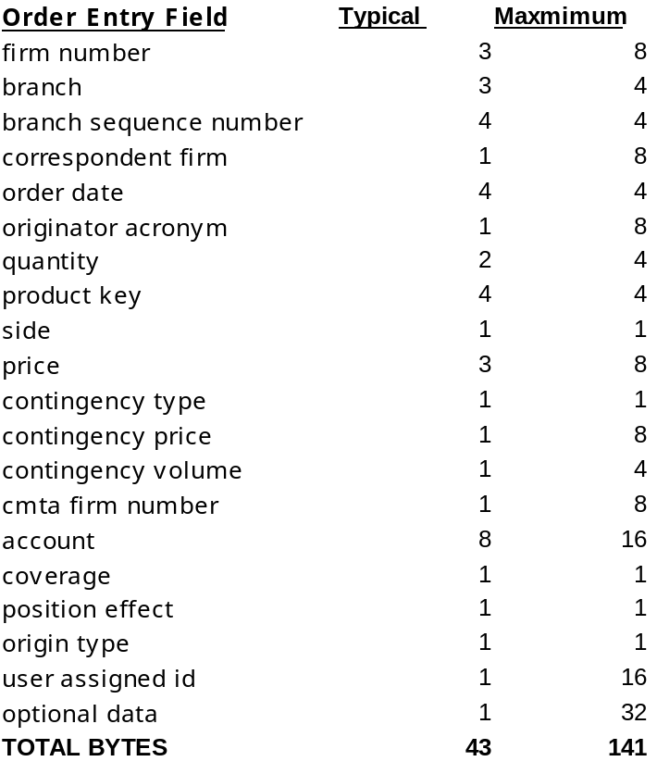
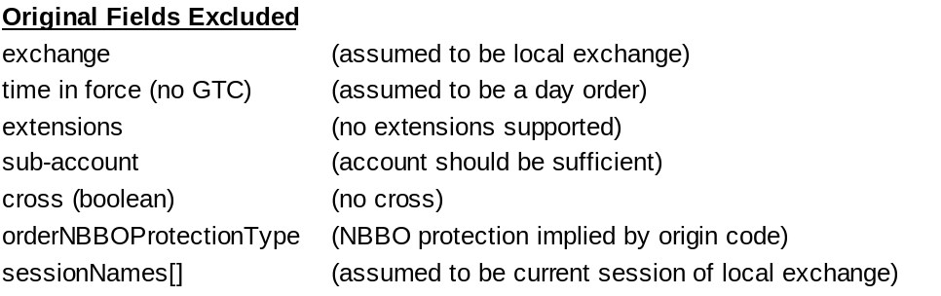

The message codec is an in-house message formatting framework, currently in production for a variety of uses.

